A Novel Clustering Approach in Wireless Sensor Network Using Genetic Algorithm and Fuzzy Logic
Fatemehzahra Gholami Tirkolaei¹, Faramarz E. Seraji²
¹Rouzbahan Institute of Higher Education, Sari, Iran, fz.gholami95@gmail.com.
²Communication Technology Dept., Iran Telecom Research Center, Tehran, Iran, feseraji@itrc.ac.ir.
Abstract — Wireless sensor network consists of hundred or thousand sensor nodes that are connected together and work simultaneously to perform some special tasks. The restricted energy of sensor nodes is the main challenge in wireless sensor network as node energy depletion causes node death. Therefore, some techniques should be exerted to reduce energy consumption in these networks. One of the techniques to reduce energy consumptions most effectively is the use of clustering in wireless sensor networks.
There are various methods for clustering process, among which LEACH is the most common and popular one. In this method, clusters are formed in a probabilistic manner. Among clustering strategies, applying evolutional algorithm and fuzzy logic simultaneously are rarely taken into account. The main attention of previous works was energy consumption and less attention was paid to delay.
In the present proposed method, clusters are constructed by an evolutional algorithm and a fuzzy system such that in addition to a reduction of energy consumption, considerable reduction of delay is also obtained. The simulation results clearly reveal the superiority of the proposed method over other reported approaches.
Keywords— Wireless sensor network, evolutional algorithms, fuzzy Logic, clustering, energy consumption.
1. Introduction
The recent advances in electronics and wireless communications have created the capabilities of design and manufacturing tiny devices called sensor nodes with low power consumption, small size, reasonable prices and variety of applications used in different industries [1-4], specifically in safety goals worldwide [5]. These nodes, which are able to receive various data via their sensors, process, and transfer them, have lead to establish and develop network called as wireless sensor network (WSN) [6]. A WSN includes numerous sensor nodes that are developed widely in an environment for collecting specified information [7]. In addition, each sensor node in the WSN is typically equipped with a radio transceiver or any other wireless telecommunications device, a small microcontroller, and an energy source such as a battery [8]. The limitation of energy sources, which are non-replaceable and non-rechargeable, is one of major challenges in WSNs. Thus, the needful algorithms are used to minimize the energy consumptions of these networks [9, 10, 11].
Clustering is an effective technique in reducing the energy consumption [12]. This means that instead of each individual node sends its own data, some nodes are selected as cluster head (CH) and others, called as cluster members, choose their nearest selected cluster heads to operate. In this way, the clusters are constructed and each cluster head receives data from its cluster members. The cluster heads sends cluster members data to the sink after fusion, aggregation and compression [13]. The most popular clustering algorithm such as LEACH (low energy adaptive clustering hierarchy) increases the lifetime of the network [14, 15].
As well, evolutionary algorithms in recent years have been used as successful evolution by designing intelligent models to cope with the challenges, and working together for optimization of an appropriate energy-aware objective function [16, 17].
In the present paper, our aim is to propose a new clustering algorithm for WSNs to reduce the power consumption, the delay, and increase the lifetime of the network by using an appropriate evolutional algorithm and fuzzy inference system. The fuzzy logic has several advantages, such as working well in noisy environment with uncertain and heterogeneous values etc., which are suitable for WSNs [18, 19].
After all, the remaining sections are organized as follows. A brief review of some heuristic and meta-heuristic hierarchical routing protocols in WSN is presented in Section II. The evaluations and the simulation results of our proposed method are presented in Section III and Section IV, respectively. Finally, the conclusion is given in Section V.
2. Related Works
In LEACH approach, a node, as a cluster head with probability , is selected [14]. Each non-cluster heads selects its cluster head so as to achieve minimum energy consumption. Cluster head roles are exchanged among the sensor nodes based on a random number from 0 to 1. A node is selected as cluster head if its random number in the current round is less than the threshold. When LEACH approaches assume homogeneous WSNs, stable election protocol (SEP) preserves hierarchical routing in heterogeneous sensor networks, where a percentage of sensor population, with respect to the remaining normal sensors in the same network, is equipped with extra energy [16].
In this paper, some significant results are achieved by changing the threshold, although using the nodes with additional capabilities is not always possible. In LEACH and SEP approaches, possibility and chances play important roles that should be managed to reduced levels.
Once the clustering problem is ascertained to be an NP-hard problem, various methods, such as evolutionary computation, are probed so as to propose new algorithms. In [18], a full inspection of the evolutionary clustering algorithms is reported, along with an investigation of differential evolution (DE) application as rugged, fast and full automatic clustering method which can solve the problems with the usual clustering approaches. In WSNs, computational intelligence (CI) and its main branch evolutionary algorithms (EA) have been customized to deal with several challenges in WSNs [20]. In the present investigation, a review of the population-based meta-heuristic field for cluster-based routing in WSN is presented by focussing on evolutionary algorithms [21].
Other population-based meta-heuristic algorithms have also been developed for the cluster-based routing problem in WSNs. The harmony search algorithm (HSA) has recently been extended to improve the longevity and reduce the energy consumption in the clustered routing of WSNs [22-25]. The fitness of a harmony solution is expressed as:
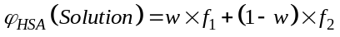 (1)
where 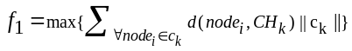 is the maximum Euclidean distance of the nodes and 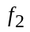 is the energy ratio of all the alive nodes in the network with the total current energy of the CH in the current round, defined as:
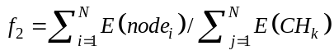 (2)
In Ref. [12], it is noted that in EA routing methods, in addition to increase of the longevity of the network, the stability time should also be considered. It is further pointed out that common EA routing methods increase network lifetime, while reducing the stability period of the network. The stability period is an interval before the first node blackout. They could increase the stability period to an acceptable level by modifying the evaluation function.
The researchers have combined the cluster scheme with the biologically inspired routing scheme to propose the evolutionary algorithms (EAs). The EAs are used to deal with the cluster-based problem for optimization of energy consumption and prolonging the network lifetime with heterogeneity, such as energy-aware evolutionary routing protocol (EAERP) [24, 26], evolutionary-based clustered routing protocol (ERP) [24], and stable-aware evolutionary routing protocol (SAERP) [27]. The ERP redesigned some significant features of EAs, which can ensure longer stable period and extend the network lifetime with efficient energy dissipation [28, 29]. The fitness function is the primary factor used to minimize network energy consumption. The SAERP has combined the principle idea of the SEP and the EAs to mainly aim at increasing the stability of the network.
3. The Proposed Method
As mentioned above, the main challenge in WSN is the limited nodes’ power supply. Thus various schemes have been introduced for reducing energy consumption among which clustering is one of the most effective one [30]. There are various methods for clustering, namely, meta-heuristic and evolutionary algorithms that are recently attended for use [31]. These techniques are able to choose appropriate cluster heads during different stages to perform clustering. There are three main steps in clustering methods assisted with evolutionary algorithms. The first step is to produce initial generation that consists of several solutions for clustering. Indeed, to produce main solutions out of which each member of generation (solution) contains several cluster heads among all nodes.
After generating an initial population of individuals, by using a fitness function, each individual will be evaluated. Then, these individuals, with pre-determined probabilities, will run through evolutionary operators (selection, recombination, mutation) to rectify their qualities. The loop of the evolutionary algorithm would continue until the termination criteria achieved. In the EAs, a complete clustered route solution is regarded as an individual, I. For a WSN with 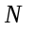 sensor nodes, each individual consists of 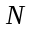 genes, the alleles of which can be either 0, 1, and -1 for non-CH nodes, CH nodes, and dead (inactive) nodes with no energy (E), respectively. Then, a population 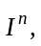 of individual solutions can be expressed as [24]:

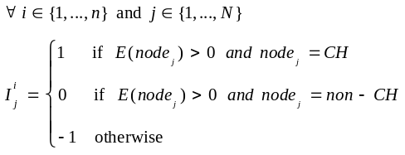 (3)
Based on the probability of the desired percentage of the CH nodes, each individual is randomly initialized with 1s and 0s [14, 15], defined as [24]:
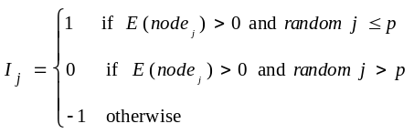 (4)
A fitness value, measured by a fitness function 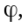 is linked with each individual, which determines numerically how good the individual is a solution for the routing optimization problem.
In the proposed approach, in order to improve network efficiency, we define fitness function such that in addition to energy consumption, delay and load balancing, must be taken into consideration. In WSNs, the distance traveled by packets, affects on efficiency, so we have to choose a solution that minimizes this distance [24]. Another parameter that has to be taken into consideration is packets end-to-end delay. Thus, it is better to choose a solution for clustering to have lowest end-to-end delay.
3.1. Design of fuzzy inference system
In order to use these heterogeneous parameters, it is better to use fuzzy inference system. By using Matlab software, we have designed a fuzzy inference system, as shown in Fig. 1, where 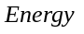 is the energy consumption, 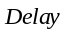 denotes the end-to-end delay and represents the distance that the packets travel in an individual [32-35].
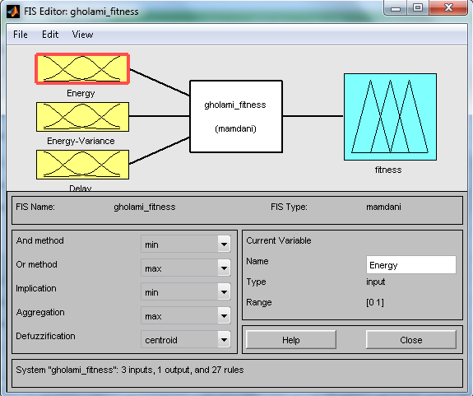
Fig. 1. Fuzzy inference system.
The values of energy, delay and distance are calculated using the following expressions:
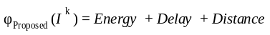 (5)
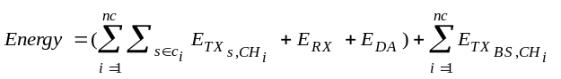 (6)
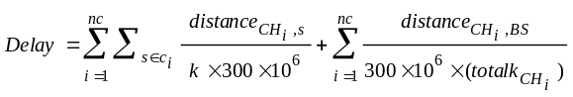 (7)
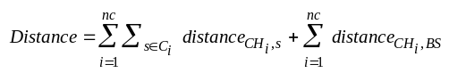 (8)
where is the total number of CHs, 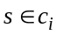 is a non-CHs linked with the i^{th} CH node, 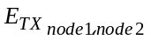 is the energy dissipated for transmitting data from 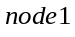 to 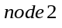 over a distance 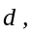 expressed as [24]:
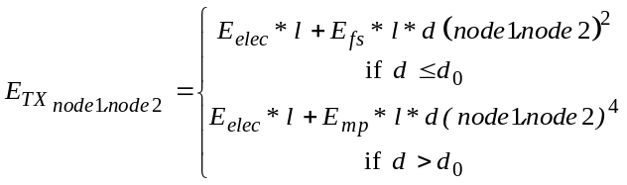 (9)
where 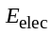 (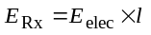) is the energy consumed to operate the transceiver circuit set to 50 nJ/bit, 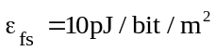 and 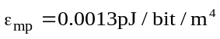 are the energies spent for transmitting l-bit data to achieve an acceptable bit error rate that depend on the transmission distance in the cases of free space model and multipath fading model, respectively [24]. If the transmission distance is less than the threshold 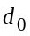, the free space model is applied; otherwise, the multipath model is used. Another parameter also taken into account is the data aggregation energy expenditure, which is set to 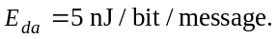 The only parameter that has not been studied in these expressions is 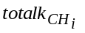which is the total packet that is sent to the 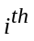 cluster head. By equating and 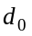 in Eq. 9, we obtain the threshold transmission distance as 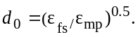
The three inputs energy, energy deviation, and delay are converted to fuzzy language variables by fuzzy logic functions [36, 37]. After converting the input variables into fuzzy variables in the fuzzy section, by using Mamdani Inference Method and the "if-then" rules in the Table 2, a fuzzy output is obtained [38, 39]. This output is in fuzzy variable mode, which should be converted into normal mode. This work is done in the non-fuzzy section and is executed by exiting membership functions. The output of this fuzzy system shows the amount of fitness of a chromosome.
Table 2 .The rules of "If-Then" in the proposed method.
- If (Energy is High) and (Energy-Variance is High) and (Delay is High) then(fitness is Medium)(1)
- If(Energy is High) and (Energy-Variance is High) and (Delay is Medium) then(fitness is Medium)(1)
- If(Energy is High) and (Energy-Variance is High) and (Delay is Low) then(fitness is High)(1)
- If(Energy is High) and (Energy-Variance is Medium) and (Delay is High) then(fitness is Medium)(1)
- If(Energy is High) and (Energy-Variance is Medium) and (Delay is Medium) then(fitness is High)(1)
- If(Energy is High) and (Energy-Variance is Medium) and (Delay is Low) then(fitness is VeryHigh)(1)
- If(Energy is High) and (Energy-Variance is Low) and (Delay is High) then(fitness is High)(1)
- If(Energy is High) and (Energy-Variance is Low) and (Delay is Medium) then(fitness is VeryHigh)(1)
- If(Energy is High) and (Energy-Variance is Low) and (Delay is Low) then(fitness is VeryHigh)(1)
- If(Energy is Medium) and (Energy-Variance is High) and (Delay is High) then(fitness is Low)(1)
- If(Energy is Medium) and (Energy-Variance is High) and (Delay is Medium) then(fitness is Low)(1)
- If(Energy is Medium) and (Energy-Variance is High) and (Delay is Low) then(fitness is Low)(1)
- If(Energy is Medium) and (Energy-Variance is Medium) and (Delay is High) then(fitness is Low)(1)
- If(Energy is Medium) and (Energy-Variance is Medium) and (Delay is Medium) then(fitness is Medium)(1)
- If(Energy is Medium) and (Energy-Variance is Medium) and (Delay is Low) then(fitness is High)(1)
- If(Energy is Medium) and (Energy-Variance is Low) and (Delay is High) then(fitness is High)(1)
- If(Energy is Medium) and (Energy-Variance is Low) and (Delay is Medium) then(fitness is High)(1)
- If(Energy is Medium) and (Energy-Variance is Low) and (Delay is Low) then(fitness is Very High)(1)
- If(Energy is Low) and (Energy-Variance is High) and (Delay is High) then(fitness is Very Low)(1)
- If(Energy is Low) and (Energy-Variance is High) and (Delay is Medium) then(fitness is Very Low)(1)
- If(Energy is Low) and (Energy-Variance is High) and (Delay is Low) then(fitness is Very Low)(1)
- If(Energy is Low) and (Energy-Variance is Medium) and (Delay is High) then(fitness is Very Low)(1)
- If(Energy is Low) and (Energy-Variance is Medium) and (Delay is Medium) then(fitness is Very Low)(1)
- If(Energy is Low) and (Energy-Variance is Medium) and (Delay is Low) then(fitness is Very Low)(1)
- If(Energy is Low) and (Energy-Variance is Low) and (Delay is High) then(fitness is Very Low)(1)
- If(Energy is Low) and (Energy-Variance is Low) and (Delay is Medium) then(fitness is Very Low)(1)
- If(Energy is Low) and (Energy-Variance is Low) and (Delay is Low) then(fitness is Low)(1)
The selection operator is next component of the proposed EAs which selects the partners using binary tournament selection from the current population and transfers them to the mating pool for reproduction [40-42].
To generate a mating pool of parents, the binary tournament selects the best individual from two randomly selected individuals of the population set and repeats these process times [43]. A specified definition of the selection operator is as follows. Let 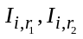 and 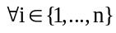 be two individuals, and and 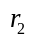 denote two uniformly distributed random numbers from the set 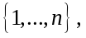 then, we can write [24]:
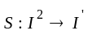
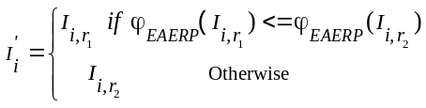 (10)
To vary the routing solutions obtained in the population, the recombination (R) and the mutation (M) perturbation operators can be used [24]. For the recombination, a proportion 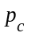 of parents’ pairs in the selected population is chosen. For each pair of parents, two cut points 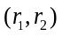 are randomly selected from the range 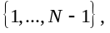 and the individuals of the participating parent 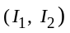 are then exchanged at alleles between these two points as given bellow [24]:
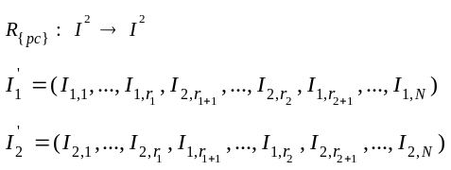 (11)
In the new individuals, each active allele is then mutated with the probability 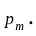 After selecting an allele for mutation, its value is reversed from 0 to 1 and vice versa [24]:
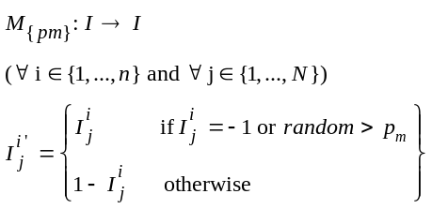 (12)
The cluster formation phase produces an initial population of solutions in each round of the routing protocol, whose fitness is then determined. Based on the fitness values, by recombination and mutation operators, the parents are selected to generate a new population. Until the termination condition of the evolutionary algorithm, this process will be repeated. In the association phase, the phenotype of the best individual, 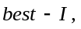 among the 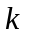 individuals in the population is counted as the clustering solution. The 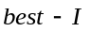 can be specified as [22]:
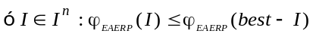 (13)
4. Evaluations
To evaluate the proposed scheme, a simulator is required that implements the proposed scheme. In this paper, we use Matlab software [32]. To evaluate the proposal, we will examine several different scenarios. We first consider a situation in which 300 sensor nodes are randomly distributed in an area. In second scenario, the number of nodes scattered randomly in the environment decreases to 200 sensor nodes in order to evaluate changes in simulation results. The third scenario is defined as having a network of 100 sensor nodes that are randomly distributed in the environment. In all the scenarios, the primary energy is equal to 0.5 J and the nodes were randomly distributed in an area of 200 mm×200 mm.
In order to start simulation, first initial parameters should be defined. Initial parameters, as shown in Table 2, contain number of nodes, deployment manner, initial energy of nodes, size of network environment, sink coordination and etc.
The superiority [37] and the longevity [44, 45] of the network of the most available methods in the field of WSN are reported in various articles. In order to measure network lifetime usually three criterions are used. First node die (FND) is considered as one of the main criterion [46, 47]. The FND means the time interval between network starts and first node depletes of energy. The next criterion is Half Node Dies (HND) that means the time interval between network starts and death of half of the nodes [48, 49]. The last criterion is considered as the time interval between network starts and death of all nodes or Last Node Dies (LND) [50].
Fig. 2, respectively, illustrate the obtained FND, HND, and LND values of LEACH, EAERP and the proposed clustering approaches in scenarios 1, 2, and 3. As we note, the proposed clustering approaches in terms of FND and HND has better performance than LEACH and EAERP.
Table 2. Initial parameters.
Parameters | Values
Number of nodes | 100, 200, 300
Network size | 200 mm×200 mm
Sink coordinate | (100,100)
Initial energy | 0.5 J
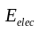 | 50 nJ/bit
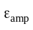 | 0.0013 pJ/bit/m²
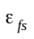 | 10 pJ/bit/m²
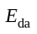 | 5 nJ/bit/signal
Data packet | 4000 bit
Control packet | 32 bit
.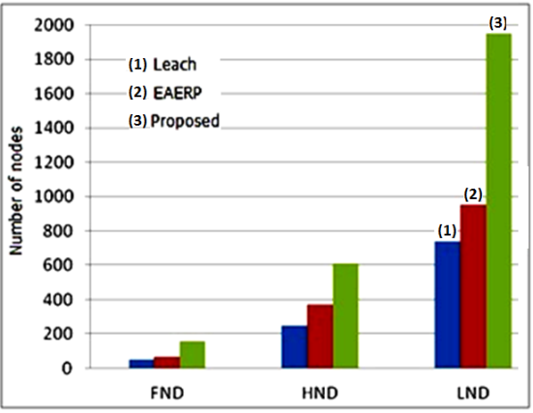 (a). 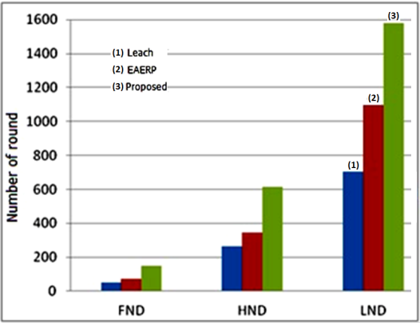 (b)
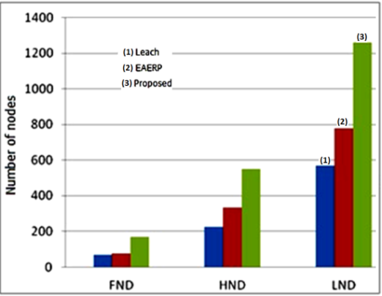 (c)
Fig. 2. FNDs and HNDs in the proposed, LEACH, and EAERP clustering approaches (a) in scenario 1, (b) scenario 2, and (c) scenario 3.
Since the fast death of a node in a WSN is usually due to the high load on that node, it can be concluded from Figs. 2a, 2b, and 2c that the proposed method could greatly increase loading, because the first shut-down of the node in the proposed design occurs much after the two methods of LEACH and EAERP [51].
The diagrams illustrated in Fig. 3 show the amount of energy consumptions, delay, and dead nodes in each round in the first scenario, respectively [51-54].
From Fig. 3, we note that number of dead nodes in each round in the proposed method is less than that of LEACH and EAERP methods. Also, the amount of energy consumptions in LEACH and EAERP in each round is more than the proposed method. Moreover, end-to-end delay in the proposed method is less than that of LEACH and EAERP methods. The results in Fig. 4, respectively, show energy consumptions, delay, and dead nodes at each round in the second scenario. As in the first scenario, based on measured metrics in second scenario, the proposed method has a better performance than LEACH and EAERP approaches.
The amount of energy consumptions in each round of network execution, delay, and dead nodes in each round in the second scenario are shown in Fig. 5. The final results of the proposed scheme for the three scenarios are presented in Table 3. We note that in the first scenario, the proposed scheme improves the useful life of the network by 68% and 59% for FND, and 60% and 39% for HND compared to the LEACH and EAERP algorithms. In the energy benchmark, the proposed scheme is 43% and 30% better than the LEACH and EAERP algorithms, respectively. The reason for this improvement is that the load balancing is done at the network level, resulting in a decrease in total energy consumption. The improvements in the proposed scheme in the second and third scenarios are comparatively significant, as given in Table 3.
Table 3: Improvement of the parameters of the proposed scheme for the three scenarios.
Improvement in comparison with: | Scenario 1 |  |  | Scenario 2 |  |  | Scenario 3
Improvement in comparison with: | Energy  (%) | HND  (%) | FND  (%) | Energy  (%) | HND  (%) | FND  (%) | Energy  (%) | HND  (%) | FND  (%)
LEACH | 43 | 60 | 68 | 64 | 89 | 60 | 45 | 57 | 65
EAERP | 30 | 39 | 59 | 48 | 76 | 55 | 38 | 43 | 52
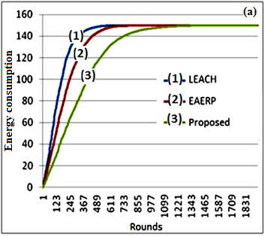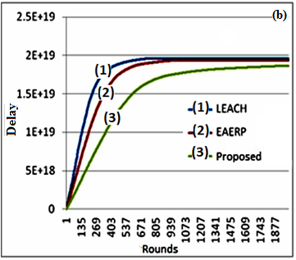
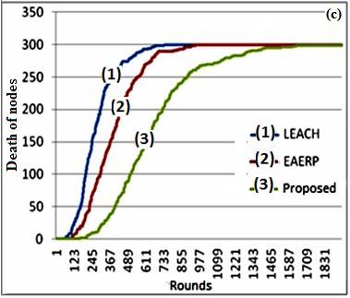
Fig. 3. (a) Energy consumption, (b) The trend of delay, and (c) The trend of nodes death in the proposed, LEACH, and EAERP clustering approaches in scenario 1.
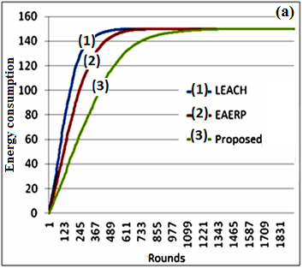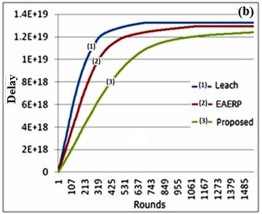
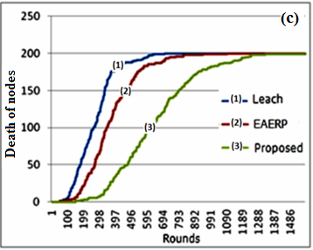
Fig. 4. (a) Energy consumption, (b) The trend of delay, and (c) The trend of nodes death in the proposed, LEACH, and EAERP clustering approaches in scenario 2.
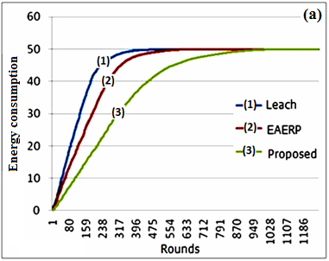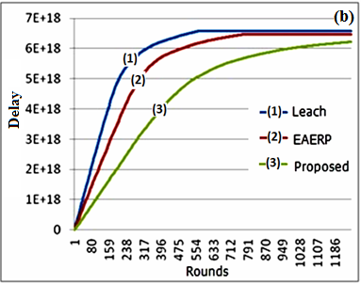
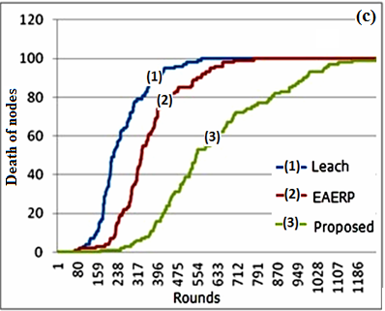
Fig. 5. (a) Energy consumption, (b) The trend of delay, and (c) The trend of nodes death in the proposed, LEACH, and EAERP clustering approaches in scenario 3.
5. Conclusion
The selection of a routing protocol for a WSN depends on different factors such as network lifetime and stability period. In this paper, an evolutionary algorithm with an appropriate fuzzy inference system as fitness function is proposed by considering the clustering intrinsic properties. The principle idea of the proposed method is involving of energy consumptions, delay, and distance in fitness function in order to improve network efficiency versus consumption of energy and delay.
Based on the simulation results, the performance of proposed method was examined in terms of energy consumption, delay and trend of dead nodes. It is shown that the proposed method has better performance in comparison to LEACH and EAERP approaches as reported in the literatures.
References
[1] I.F. Akyildiz, W. Su, Y. Sankarasubramaniam, E. Cayirci, “Wireless sensor networks: A survey”, Computer Nets., Vol. 38 pp. 393–422, 2002.
[2] Anna Ha´c, Wireless Sensor Network Designs, John Wiley & Sons Ltd, The Atrium, Southern Gate, Chichester, West Sussex PO19 8SQ, England, 2003.
[3] C. S. Raghavendra, Krishna Sivalingam, Taieb Znati (Eds.), Wireless Sensor Networks, Kluwer Academic Publishers New York, 2004.
[4] Kazem Sohraby, Daniel Minoli, Taieb Znati, Wireless sensor networks: technology, protocols, and applications, John Wiley & Sons, Inc., New Jersey, USA, 2007.
[5] Nirupama Bulusu, Sanjay Jha (Eds.), Wireless Sensor Networks, ARTECH House, Inc., Norwood, USA, 2005.
[6] Daniele Puccinelli and Martin Haenggi, “Wireless Sensor Networks: Applications and Challenges of Ubiquitous Sensing”, pp. 19-29, IEEE Circuit Sys. Mag., Third Quarter, 2005.
[7] A. Swami, Q. Zhao, Y.-W. Hong and L. Tong, Wireless sensor networks: signal processing and communications perspectives, John Wiley & Sons, Ltd., Chichester, West Sussex, England, 2007.
[8] Yunhuai Liu, Hoilun Ngan, and Lionel M. Ni, “Power-Aware Node Deployment in Wireless Sensor Networks”, Int. J. Distributed Sensor Nets., Vol. 3, pp. 225–241, 2007.
[9] [1] Won.Yong Shin, Sae-Young Chung, Yong H. Lee, "Parallel Opportunistic Routing in Wireless Networks", pp. 6290-6300, IEEE Trans. Info. Theo., Vol. 59, Iss. 10, 2013.
[10] Jason Lester Hill, "System architecture for wireless sensor networks," Ph.D. dissertation, University of California at Berkeley, 2003.
[11] Costis Kompis and Prateek Sureka (Eds.), Technologies to Enable Remote and Wireless Sensing, ESP Central Ltd., UK, 2010.
[12] Mauri Kuorilehto, Mikko Kohvakka, Jukka Suhonen, Panu Hämäläinen, Marko Hännikäinen, and Timo D. Hämäläinen, Ultra-Low Energy Wireless Sensor Networks in Practice: Theory, Realization and Deployment, John Wiley & Sons Ltd, The Atrium, Southern Gate, Chichester, West Sussex, England, 2007.
[13] J. Zheng and A. Jamalipour (Eds.), Wireless Sensor Networks: A Networking Perspective, John Wiley & Sons Inc. Publication, 2009.
[14] Wendi Rabiner Heinzelman, Anantha Chandrakasan, Hari. Balakrishnan, “Energy-Efficient Communication Protocol for Wireless Microsensor Networks”, Proc. IEEE Int. Conf. Sys. Sci., Jan. 4-7, Maui, Hawaii, pp. 1-10, 2000.
[15] Ying Zhang, Jun Wang, Dezhi Han, Huafeng Wu, and Rundong Zhou, “Fuzzy-Logic Based Distributed Energy-Efficient Clustering Algorithm for Wireless Sensor Networks”, Sensors, Vol. 17, No. 1554 pp. 1-21, 2017. doi: 10.3390/s17071554.
[16] Vairam T.; Kalaiarasan C., “Intelligent Multipath Routing in Wireless Sensor Network Using Genetic Algorithm”, Int. J. Appl. Eng. Res., Vol. 10, Iss. 4, pp. 11475-11485, 2015.
[17] Muneer Bani Yassein, Firas Albalas, Alaa Odeh, “Energy-Aware objective function for RPL Routing in Internet of Things” Int. J. Commun. Anten. Propag., Vol. 7, No. 3, 2017. doi: 10.15866/irecap.v7i3.11741.
[18] A. Jain, B.V. Ramanareddy, A Novel Method of Modeling Wireless Sensor Network Using Fuzzy Graph and Energy Efficient Fuzzy Based k-Hop Clustering Algorithm, Wireless Personal Commun., Vol. 82, Iss. 1, pp 157-181, 2015.
[19] Song Mao, Chenglin Zhao, Zheng zhou, Yabin Ye, “An improved fuzzy unequal clustering algorithm for wireless sensor networks”, Mob. Net. App., Vol. 18, No. 2, pp.206-214, 2013. doi: 10.1007/s11036-012-0356-4.
[20] P. K. Singh, D. K. Yadav, S. Dixit, “Modified Stable Election Protocol (M-SEP) for Wireless Sensor Network”, Int. J. Advan. Res. Electron. Commun. Eng. (IJARECE), Vol. 4, Iss. 4, pp. 761-764, 2015.
[21] Amit Sarkar and T. Senthil Murugan, “Routing protocols for wireless sensor networks: What the literature says?”, Alexandria Eng. J., Vol. 55, pp. 3173-3183, 2016. doi: 10.1016/j.aej.2016.08.003.
[22] B. A. Attea, E. A. Khalil, “A new evolutionary based routing protocol for clustered heterogeneous wireless sensor networks”, Appl. Soft Comput., Vol. 12, pp.1950–1957, 2012.
[23] [10] Sajid Hussain, Abdul Wasey Matin, Obidul Islam, “Genetic algorithm for energy efficient clusters in wireless sensor networks”, Proc. 4th Int. Conf. Info. Technol., New Generations, ITNG, IEEE Comput. Soc., Apr. 2-4, Lasvegas, Nevada, USA, pp. 147–154, 2007.
[24] Enan A. Khalil, Bara’a A. Attea, “Energy-aware evolutionary routing protocol for dynamic clustering of wireless sensor network”, Swarm and Evolution. Compu., Vol. 1, No. 4, pp.195-203, 2011. doi: 10.1016/j.swevo.2011.06.004.
[25] N. M. Abdul Latiff, C. C. Tsimenidis, B. S. Sharif, “Energy-Aware Clustering for Wireless Sensor Networks Using Particles Swarm Optimization”, 8th Ann.IEEE Int. Symp. Pers., Indoor and Mob. Radio Commun. (PIMRC'07), 2007. doi: 10.1109/PIMRC.2007.4394521.
[26] E. A. Khalil, B. A. Attea, “Stable-Aware Evolutionary Routing Protocol for Wireless Sensor Networks”, Wireless Pers. Commun., Vol. 69, pp. 1799–1817, 2013.
[27] Marziyeh Moshayedi and Mehdi Sadeghzadeh, “Application of Routing Methods to Reduce Energy Consumption in Wireless Sensor Networks”, Int. J. Comp. & Info. Tech., (2017) 5(1): 59-71.
[28] E. Srie Vidhya Janani and P. Ganesh Kumar, “Energy Efficient Cluster Based Scheduling Scheme for Wireless Sensor Networks”, Scientific World J., Vol. 2015, pp. 2-9, 2015.
[29] Tifenn Rault, Abdelmadjid Bouabdallah, Yacine Challal, “Energy Efficiency in Wireless Sensor Networks: a top-down survey”, Comput. Nets., Vol. 67, No. 4, pp.104-122, 2014.
[30] Geetha. V., Pranesh.V. Kallapur, Sushma Tellajeera, “Clustering in Wireless Sensor Networks: Performance Comparison of LEACH & LEACH-C Protocols Using NS2”, Procedia Technol., Vol. 4, pp. 163–170, 2012.
[31] Sariga Arjunan and Pothula Sujatha, “A survey on unequal clustering protocols in Wireless Sensor Networks”, J. King Saud Univ.-Comput. Info. Sci., Vol. 31, Iss. 3, pp. 304-317, 2019.
[32] Fuzzy Logic Toolbox™ User's Guide, The MathWorks, Inc., 3 Apple Hill Drive Natick, MA 01760-2098, 2016.
[33] M. Gloria Sanchez-Torrubia, Carmen Torres-Blanc, Sanjay Krishnankutty, “Mamdani's Fuzzy Inference eMathTeacher: A Tutorial for Active Learning” WSEAS Trans. Comput.", Vol. 7, No. 5; pp. 363-374, 2008. ISSN 1991-8755.
[34] S. N. Sivanandam, S. Sumathi and S. N. Deepa, Introduction to Fuzzy Logic using MATLAB, Springer-Verlag Berlin Heidelberg, 2007.
[35] J.-S. Roger Jang and Ned Gulley, MATLAB-Fuzzy Logic Toolbox, Version 1. The MathWorks, Inc., USA, 1997.
[36] H.-J. Zimmermann, Fuzzy Set Theory and Its Applications, Third Edition, Kiuwer Academic Publishers Boston, USA, 1996.
[37] Soumitra Das, S. Barani, Sanjeev Wagh, and S. S. Sonavane, “Extending lifetime of wireless sensor networks using multi-sensor data fusion”, Sadhana, Vol. 42, No. 7, pp. 1083–1090, 2017.
[38] E. H. Mamdani and S. Assilian, “An Experiment in Linguistic Synthesis with a Fuzzy Logic Controller,” Int. J. Man-Machine Studies, Vol. 7, No. 1, 1975, pp. 1-13. doi:10.1016/S0020-7373(75)80002-2.
[39] Jyh-Shing Roger Jang, Chuen-Tsai Sun, and Eiji Mizutani, Neuro-Fuzzy and Soft Computing, Prentice Hall, Upper Saddle River, NJ, USA, 1997.
[40] Kalyanmoy Deb, “An introduction to genetic algorithms”, Sadhana, Vol. 24, Parts 4 & 5, pp. 293-315, 1999.
[41] Saneh Lata Yadav and Asha Sohal, “Comparative Study of Different Selection Techniques in Genetic Algorithm”, Int. J. Eng., Sci. and Math., Vol. 6, Iss. 3, 2017.
[42] Anupriya Shukla, Hari Mohan Pandey, and Deepti Mehrotra, “Comparative Review of Selection Techniques in Genetic Algorithm”, IEEE Int. Conf. Futuristic Trends in Computational Analysis and Knowledge Management, Feb. 2015. doi: 10.1109/ABLAZE.2015.7154916.
[43] Anju Bala, “A Review of Selection strategies in Genetic Algorithm”, Int. J. Adv. Res. Comput. Sci. and Manage. Studies, Vol. 5, Iss. 6, pp. 133-141, 2017.
[44] Mohamed Younis and Kemal Akkaya, “Strategies and techniques for node placement in wireless sensor networks: A survey”, Ad Hoc Nets., Vol. 6, pp. 621–655, 2008.
[45] Yuchao Chang, Hongying Tang, Yongbo Cheng, Qin Zhao, Baoqing Li, and Xiaobing Yuan, “Dynamic Hierarchical Energy-Efficient Method Based on Combinatorial Optimization for Wireless Sensor Networks”, Sensors, Vol. 17, 1665, pp. 1-15, 2017. doi: 10.3390/s17071665.
[46] Naveen Chawla and Ashish Jasuja, “First Node Die (FND) Time Enhancement in LEACH Protocol”, Int. J. Sci. Res. (IJSR), Vol. Vol. 3, Iss. 12, pp. 2306-2309, 2014.
[47] Naveen Chawla and Ashish Jasuja, “Algorithm for Optimizing First Node Die (FND) Time in LEACH Protocol”, Int. J. Current Eng. Technol., Vol. 4, No.4, pp. 2748 -2750, 2014.
[48] Mustapha Reda Senouci, Abdelhamid Mellouk, Amar Aissani, and Hadj Senouci, “Performance Evaluation of the Network Lifetime for Routing Protocols in WSN”, 7th Int. Wireless Commun. Mob. Computing Conf., July 2011, Istanbul, Turkey. doi: 10.1109/IWCMC.2011.5982869.
[49] Tejinder Kaur1, Manpreet Singh, and Silki Khurana, “To Increase the Lifetime by Using Grid Optimization and Energy Efficient Clustering Scheme in Wireless Sensor Network”, Int. J. Wireless Commun. and Networking Technol., Vol. 3, No. 5, pp. pp. 82-86, 2014.

[50] Tejinder Kaur; Manpreet Singh, Lifetime enhancement by optimization of grid using mobility and energy proficient clustering technique of wireless sensor network”, 2016 3rd Int. Conf. Computing for Sustainable Global Development (INDIACom), New Delhi, India, 16-18 March 2016.
[51] Santosh Vishnu Purkar and R.S.Deshpande, “A Review on Energy Efficient Clustering Protocols of Heterogeneous Wireless Sensor Network”, Int. J. Eng. Technol. (IJET), Vol. 9, pp. 2514-2527, 2017. doi: 10.21817/ijet/2017/v9i3/170903342.
[52] Santosh V. Purkar and R. S. Deshpande, “Energy Efficient Clustering Protocol to Enhance Performance of Heterogeneous Wireless Sensor Network: EECPEP-HWSN” J. Computer Net. Commun., Vol. 2018, pp. 1-12, Article ID 2078627, 2018.
[53] Yi, D. and Yang, H., 2016. “HEER-A delay-aware and energy-efficient routing protocol for wireless sensor networks”, Comput. Nets., Vol. 104, pp. 155-173, 2016.
[54] M. Bajelan and H. Bakhshi, “An Adaptive LEACH-based Clustering Algorithm for Wireless Sensor Networks”, J. Commun. Eng., Vol. 2, No. 4, pp. 351-365, 2013.

